Task No 01: Show the Output of all Examples mentioned in the Lab.

Example No 01:

Input:

using System;

using System.IO;

using System.Text;

namespace CP_Lab_Tasks

{

class Program

{

static void Main(string[] args)

{

var path = @"C:\Users\ESHOP\source\repos\ConsoleApp1\ConsoleApp1\bin\File.txt";

string content = File.ReadAllText(path, Encoding.UTF8);

Console.WriteLine(content);

}

}

}

Output:

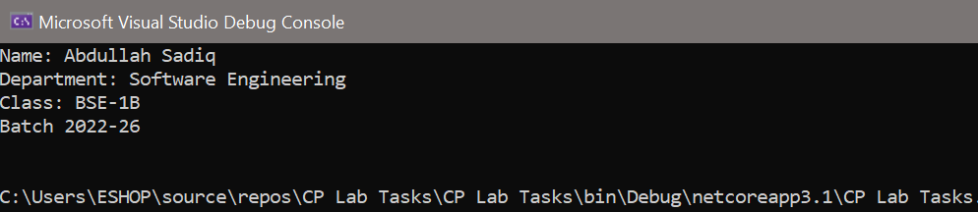

Example No 02:

Input:

using System;

using System.IO;

using System.Text;

namespace ReadAllLines

{

class Program

{

static void Main(string[] args)

{

var path = @"C:\Users\ESHOP\source\repos\ConsoleApp1\ConsoleApp1\bin\File.txt";

string[] lines = File.ReadAllLines(path, Encoding.UTF8);

foreach (string line in lines)

{

Console.WriteLine(line);

}

}

}

}

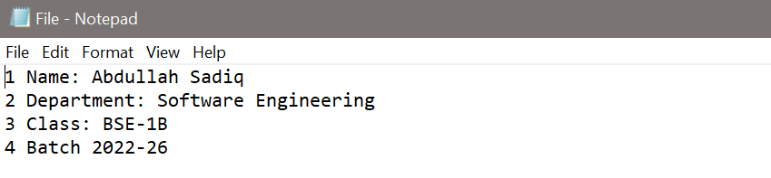

Output:

Example No 03:

using System;

using System.IO;

using System.Text;

namespace StreamReaderReadToEnd

{

class Program

{

static void Main(string[] args)

{

var path = @"C:\Users\ESHOP\source\repos\ConsoleApp1\ConsoleApp1\bin\File.txt";

using var fs = new FileStream(path, FileMode.Open, FileAccess.Read);

using var sr = new StreamReader(fs, Encoding.UTF8);

string content = sr.ReadToEnd();

Console.WriteLine(content);

}

}

}

Output:

Example No 04:

Input:

using System;

using System.IO;

using System.Text;

namespace ConsoleApp60

{

class Program

{

static void Main(string[] args)

{

var path = @"C:\Users\ESHOP\source\repos\ConsoleApp1\ConsoleApp1\bin\File.txt";

using var fs = new FileStream(path, FileMode.OpenOrCreate, FileAccess.Write);

using (StreamWriter writer = new StreamWriter(fs, Encoding.UTF8))

{

Console.WriteLine("Enter Your Name");

string name = Console.ReadLine();

writer.WriteLine("Name is {0}", name);

}

}

}

}

Output:

Task No 02: Design a program of Employee in which you must take information of 05 employees. Information includes (employee_id, name, date of birth, email, residential address, job title, salary…etc.) and save all the records in a txt file using Stream Writer.

Input:

using System;

using System.IO;

using System.Text;

namespace CP_Lab_Tasks

{

class Program

{

static void Main(string[] args)

{

int EMPId;

string EMPNAME, EMPDOB, EMPEMAIL, EMPADD, EMPJOB;

double EMPSAL;

string path = @"File.txt";

var fileStream = new FileStream(path,

FileMode.OpenOrCreate, FileAccess.Write);

using (StreamWriter writer = new StreamWriter(fileStream))

{

for (int i = 0; i < 5; i++)

{

Console.WriteLine("Enter {0} Employee Id: ", i + 1);

EMPId = int.Parse(Console.ReadLine());

Console.WriteLine("Enter {0} Employee Name: ", i + 1);

EMPNAME = Console.ReadLine();

Console.WriteLine("Enter {0} Employee Date of Birth: ", EMPNAME);

EMPDOB = Console.ReadLine();

Console.WriteLine("Enter {0} Employee Email: ", EMPNAME);

EMPEMAIL = Console.ReadLine();

Console.WriteLine("Enter {0} Employee Address: ", EMPNAME);

EMPADD = Console.ReadLine();

Console.WriteLine("Enter {0} Employee Job Title:", EMPNAME);

EMPJOB = Console.ReadLine();

Console.WriteLine("Enter {0} Employee Sallary: ", EMPNAME);

EMPSAL = double.Parse(Console.ReadLine());

//now inserting into file

writer.WriteLine(EMPId + " " + EMPNAME + " " + EMPDOB + " " + EMPEMAIL + " " + EMPADD + " " + EMPJOB + " " + EMPSAL);

Console.Clear();

}

}

}

}

}

Output:

